INFT1150

Assignment 2 - Foundations of Information Systems
Ethan Bentley, Aaron Smith & Jay Rovacsek

Table of Contents
Executive Summary 2
Student Team Profile 3
Project Description 4
Project Goals 5
Business Aims 6
Description of Development Process Used 7
Use Cases and IS structures 8
Use Case Scenarios 10
System Diagram 11
Description of System 12
Password Recovery 12
Elements of usability and how they are incorporated into the system 14
Appendix A - Group process evaluation by each member 16
Appendix B - System Elements 17
References: 18

Executive Summary

Student Team Profile

Jay Rovacsek
c3146220
Bbus/BIT
jay.rovacsek@uon.edu.au / elevennn@protonmail.com
https://github.com/RandomGeneric
About: Enthusiast of tech, learning a number of languages; Python, C#, Web-development languages, SQL, Bash.

Ethan Bentley
c########
Ethan.Bentley@uon.edu.au / bentley.ethan@gmail.com

Aaron Smith
c########
asmith20@uon.edu.au / as16091988@bigpond.com

Project Description

BoN is an online bank which aims to adapt to modern advancements in technology. Through the use of this adaptation BoN can deliver the same service as current brick and mortar banks as well as go above and beyond the capabilities of these already established banks.

Reducing overhead fees such as renting a physical location will allow reduced account rates and fees for customers. Access to current information and integration of investment opportunities into our online services gives younger customers the opportunity to invest their money in areas such as shares.

All services provided by BoN can be accessed externally by its customers, allowing customers to do their banking from anywhere in the world.
Which also allows BoN to provide customer service to anyone, anywhere at any time. This ease of access provides incentive for the younger generation of customers who are technologically acute and have confidence in online banking.

Project Goals

There is a number of goals to this project;
- Create a server which serves content via the Django framework.
- Create and maintain a private github repository to enable means to collaboratively work. (Private repository)
- Create a working mock-up of a bank login page served via django using jinja logic to create highly modular pages.
- Have working authentication and verification of input on login page using SQL validation of userID / Password.
- Create a valid and working account overview page serving details of account balance and details via SQL.
- Create a valid and working transfer page modifying SQL database to reflect changes.
- Have validation of input on transfer page by HTML5 validation, alternatively javascript.
- Documentation of project in the form of this report.
- Provide an online service that is fast, reliable and consistent.
- Have no “brick and mortar” locations to reduce overhead costs.
- Provide fast customer service and tech support.
- Provide a more appealing method of access to banking for specifically the younger demographic.
- Get a HD in this course.

Business Aims
Business goals include a number of main focuses.
These aims are partially covered by this project, some of them however straddle the line of within course material and outside the scope of expectation of this course. Not that we are attempting to avoid work, but instead trying to keep the material and system creation within a manageable and reasonable range for what should be expected from this assignment.
The first aim of the Bank of Newcastle is to provide a secure, easy-to-use system in which to perform online banking functionality. This aim specifically has a large number of issues and considerations to be discussed within later parts of the assignment.
A secondary aim of the Bank of Newcastle is to ensure that consumer data is safe and handled correctly in the process of maintaining and hosting the consumers data. This is another point in which discussion will occur in a later segment of the report.

Description of Development Process Used

In order to develop the BoN application our team came to the consensus that Django would be an appropriate framework to use. The team favoured Django over other web development applications due to the large amount of online resources available in terms of documentation, video guides, how to guides, references and topic guides. As well as our group members being familiar with coding in Python, being the language that Django primarily uses.

To achieve the business goals of the BoN our team needed a development process which would allow for rapid development, extensible and modular design which Django excels at.
Django subscribes to the ‘don’t repeat yourself’ mentality. Allowing developers to create projects in modular parts known as ‘Apps’ which are ‘pluggable’ and ‘re-usable’. Code that has already been developed to meet the needs of a certain process can be adapted and used for multiple applications.

Due to the way the code is created extensibly the project is also incredibly easy to scale up in order to meet the requirements of system growth.

Use Cases and IS structures

Part of System | Requires
Online (Operational) System | -Website and Mobile App  -Customer Accounts and Login details
Customer Support | -Customer support page  -Employees for online or phone support.
Account Management | -Password recovery  -Account Information update  -Send payment authorization
Technical Administration | -System Administrator  -Servers to host online system  -System security  -Security officer
Customers (User) | -Create account  -Transfer Money  -Withdraw Money  -Deposit Money  -Change account details  -Invest Money  -Take out loan  -Increase daily limit  -Authorize payments

Customer > System > Account Management

Account Management comprises of:
- Withdraw
- Deposit
- Create account
- Delete account
- Modify Account
- Transfer functionality

Use Case Scenarios
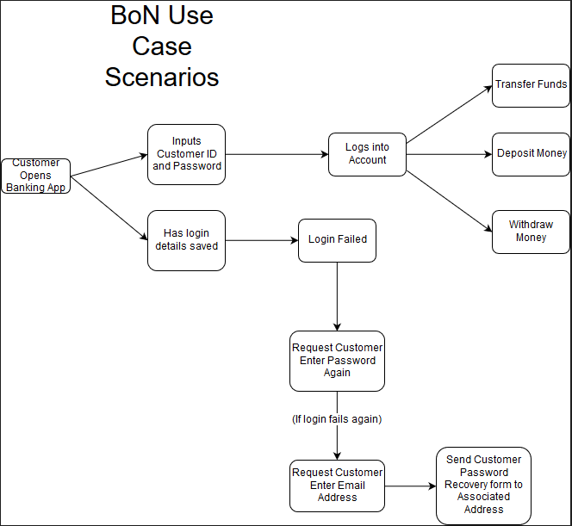

System Explanation and Member Thoughts
Django was chosen as an extensible framework which used a familiar language which all members had learnt to a degree before.
What was not expected was the more complex integration and requirements that married into the chosen framework, while a number of key objectives have been achieved and we are quite happy with the progress that was achieved for the project, it is undoubtedly the case that more time and resource would have always have proven a boon to the team. While the team was enthusiastic about completing the solution to this project that would satisfy all aims included with the business it must be expected that a number of these projects would never come to fruition.
Anyways.

Initial System Install:
We start with initialising the Django framework, this can be done by downloading and installing Python 3.4 on Windows, Mac OSX or using the generally pre-installed python 3.* packages on UNIX derivatives such as Linux and it’s various flavours and BSD solutions.
Once python is installed, it is generally easiest and best practice to install the pip utility via a python script supplied on the pip.io host site. Pip enables us the ability to use the pip.exe/pip.py files to call commands from a CLI interface such as “pip install django”.
Members of the group found that Django framework also has solutions available to Linux systems in use, via cloning of the git repository hosting the Django development and compiling the packages required on the system, this proved a problem later however in ensuring continuity and uniformity in not only source code within the project and slightly differing conventions in some methods required to run and maintain the server during development. Ultimately all users from here-forth developed under the Windows system.
In hindsight, the best method of development for the project may have instead been to initialise a hosted VPS service such as Digital Ocean, this would have allowed all users to not only developed on the same system as each-other, but also ensured installation of systems such as the SQL back-end and integration with Django were uniform in design.
An alternative to the above would have been a self hosted system which any of the members could have setup an appropriate environment in which to emulate a VPS.

Collaborative work on the GitHub platform:
Once Python, Pip and Django are installed on a host of choice, a CLI interface should be directed to the parent folder that the user wishes to install the project, in our case a freshly initialised git repository which proved to be a decent method in which to collaboratively develop and host code in an environment less susceptible to common hardware failure such as hard drive failure or “bit-rot” which also could occur on files on a system and not have a system in which to detect the changes or self healing file-systems unlike the GitHub system offers.
As stated above, GitHub proved an elegant solution to us, as we were only able to physically meet a handful of times during the development of the process.

First Application and Initial Settings tweaks:
Once we had a main project created, we were able to change directory to the project, and run the server straight away with the command “python manage.py runserver”, now this of-course is void of any material to begin with as we had not created any “applications” yet.
By running “python manage.py startapp $APPNAME” we are able to create as many apps as we wish. Our project ended up having a homepage, login, account and about application choice. We did not require any more to satisfy the requirements of the project, however we could easily create a number more highly extensible applications to improve and build on our project very quickly.
A number of modifications needed to occur on each application, as well as the project settings contained within Bankapp/settings.py;
'homepage.apps.homepageConfig',
'login.apps.loginConfig',
'account.apps.accountConfig',
'transfer.apps.transferConfig',
'about.apps.aboutConfig',
Were added to the installed apps settings subsection, Database settings were modified to include;
'default': {
'ENGINE': 'django.db.backends.mysql',
'NAME': 'bank_database',
'USER': 'root',
'PASSWORD': 'ebsql',
'HOST': 'localhost',
'PORT': '3306',}
Which allowed intergration into a locally installed MySql server which proved troublesome at best during the project’s lifespan.

System Diagram
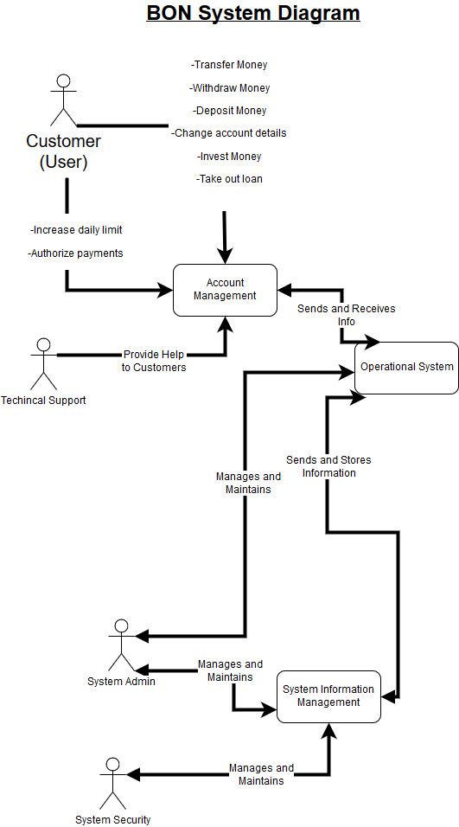

Description of System

The BoN requires a customer portal system that allows the functionality of the following system processes:

Account Register:
- New customer to the BoN accesses the homepage.
- Homepage contains a link to login to account.
- Login page has Username and Password fields and also contains a link for ‘New Customer”.
- New customer clicks link and is taken to register page.
- Customer fills in their details.
- Account is created for new customer.
- New customer can now login to account through homepage link.

Funds Transfer:
- Customer can open an application or web-portal to the system.
- Customer can enter account login details and password or can create a new account login if it currently doesn’t exist.
- An authentication system that allows legitimate users to access their own accounts only.
- A customer can enter recipient's (Their own or another individual's) Account Information including; Acc #number, BSB and a description of the transfer.
- (Opt) Set up automatic payment if required, fill in regular payment field.
- (Opt) if new recipient, send email, SMS with code to verify payment.
- Ask user to ‘check information is correct and confirm payment’
- Generate user receipt with ‘print’ button.

Password Recovery:
- Customer can request password recovery.
- System requests customers email associated with the account.
- System sends password recovery form to customers email.
- Customer enters new password (twice to confirm).
- Database is updated with customers updated account login details.

Technical Support:
- Customer can access technical support online chat or phone number on homepage.
- Technical support advises customer on how to resolve technical issue.

Elements of usability and how they are incorporated into the system

The BoN is exclusively an online bank, therefore the emphasis should be for it to meet the needs of its customers in a technical aspect so that the service can be accessed by whoever the customer may be and through their own personal means to access BoN’s service.

It needs to be accessible through the multitude of devices that users may choose to use. Such as Mobile devices: Apple, Samsung, Tablets, PC’s, etc.
It must also be accessible through different types of software such as IOS, Windows, MacOS, UNIX and derivatives of UNIX.
A multitude of different browsers software need to be considered including: Safari, Firefox and derivatives, Chromium and derivatives, Opera, and various other browsers.

Therefore the minimum system requirements of a user connecting to the operational system should be designed in a conservative manner. The login time should be no longer than 3(seconds) maximum, regardless of the device being used to connect to the system.

BoN’s online system needs to be reliable and secure. Therefore the system security must be able to integrate with the platforms on which the service is available.
The system needs to have security which reflects the nature in which the service is being accessed.

There must be a focus on technical and customer support to encourage customers to use the service over other providers. Account management needs to be clear and concise, as well as reliable and easily accessible in by various methods
Some examples include: phone, email, or via a messaging system within the operational system.
No external programs should need to be downloaded when accessing the service through a browser and no security features should need to be installed on the customers device. The system security needs to be managed on the server side rather than the end user.

Appendix A - Group process evaluation by each member.

Appendix B - System Elements

References:

https://www.djangoproject.com/
https://github.com/RandomGeneric/INFT1150
https://docs.djangoproject.com/en/1.11/
https://www.youtube.com/watch?v=FNQxxpM1yOs&list=PLQVvvaa0QuDeA05ZouE4OzDYLHY-XH-Nd
https://www.python.org/download/releases/3.4.0/
https://www.python.org/downloads/mac-osx/
https://bootstrap.pypa.io/get-pip.py
https://github.com/django/django
https://github.com/RandomGeneric/INFT1150
https://en.wikipedia.org/wiki/Data_degradation
https://www.quora.com/What-filesystem-does-GitHub-use-for-its-repositories-and-why

